

**ATAR**

**PHYSICS**

**UNITS 1 & 2**

**2017**

Name: _______________________________________________________

***TIME ALLOWED FOR THIS PAPER***

Reading time before commencing work: Ten minutes

Working time for the paper: Three hours

***MATERIALS REQUIRED/RECOMMENDED FOR THIS PAPER***

**To be provided by the supervisor:**

* This Question/Answer Booklet; Formula and Constants sheet

**To be provided by the candidate:**

* Standard items: pens, pencils, eraser or correction fluid, ruler, highlighter.
* Special items: Calculators satisfying the conditions set by the SCSA for this subject.

***IMPORTANT NOTE TO CANDIDATES***

No other items may be taken into the examination room. It is **your** responsibility to ensure that you do not have any unauthorised notes or other items of a non-personal nature in the examination room. If you have any unauthorised material with you, hand it to the supervisor **before** reading any further.

**Structure of this paper**

|  |  |  |  |  |  |
| --- | --- | --- | --- | --- | --- |
| Section | Number of questions available | Number of questions to be answered | Suggested working time  (minutes) | Marks available | Percentage of exam |
| Section One:  Short answer | 12 | 12 | 50 | 54 | 30 |
| Section Two:  Extended answer | 7 | 7 | 90 | 90 | 50 |
| Section Three:  Comprehension  and data analysis | 2 | 2 | 40 | 36 | 20 |
|  |  |  | **Total** | 180 | 100 |

**Instructions to candidates**

1. The rules for the conduct of Western Australian external examinations are detailed in the *Year 11 Information Handbook 2017.* Sitting this examination implies that you agree to abide by these rules.
2. Write your answers in this Question/Answer Booklet.
3. When calculating numerical answers, show your working or reasoning clearly. Give final answers to **three** significant figures and include appropriate units where applicable.

When estimating numerical answers, show your working or reasoning clearly. Give final answers to a maximum of **two** significant figures and include appropriate units where applicable.

1. You must be careful to confine your responses to the specific questions asked and follow any instructions that are specific to a particular question.
2. Spare pages are included at the end of this booklet. They can be used for planning your responses and/or as additional space if required to continue an answer.
   * Planning: If you use the spare pages for planning, indicate this clearly.
   * Continuing an answer: If you need to use the space to continue an answer, indicate in the original answer space where the answer is continued, i.e. give the page number. Refer to the question(s) where you are continuing your work.

**Section One: Short response 30% (54 Marks)**

This section has **twelve** **(12)** questions. Answer **all** questions. Write your answers in the space

provided. Suggested working time for this section is 50 minutes.

**Question 1 (3 marks)**

The intensity of an earthquake wave 120 km from its focus (origin) is measured to be

1.25 x 106 Wm-2. Calculate the intensity of the same wave 480 km from its focus.

**Question 2 (5 marks)**

100 g of ice is taken from a freezer where it is kept at -6.00°C. It is heated till it becomes steam at 1.10 x 102 °C. Calculate how much energy it has absorbed.

**Question 3 (5 marks)**

A 0.10 kg hockey puck is at rest. A force of 20.0 N acts on it for 0.20 s, which sets it in motion. Over the next 2.00 s it encounters an average of 0.40 N frictional force. Lastly, a force of 24.0 N acts for 0.05 s in the direction of motion. Calculate the puck’s final speed.

**Question 4 (3 marks)**

Devil’s Lair is a small cave near Margaret River, South of Perth. Its name comes from the Tasmanian Devil remains found amongst other bones in the cave. Artefacts from the cave show that aboriginal people have been living in the area for up to 5.0 x 104 years. A sample of petrified wood from a spear shaft has a measured carbon-14 decay rate of 1.70 counts per minute per gram. The decay rate of carbon-14 in fresh wood today is 13.6 counts per minute per gram. Calculate the age of the spear shaft, in years. The half-life of C-14 is 5730

years.

**Question 5 (4 marks)**

Horsepower (hp) is an old unit to measure Power, the rate at which work is done. The diagram below shows that 1.00 hp is needed to lift a 75.0 kg mass by 1.00 metre in 1.00 second.

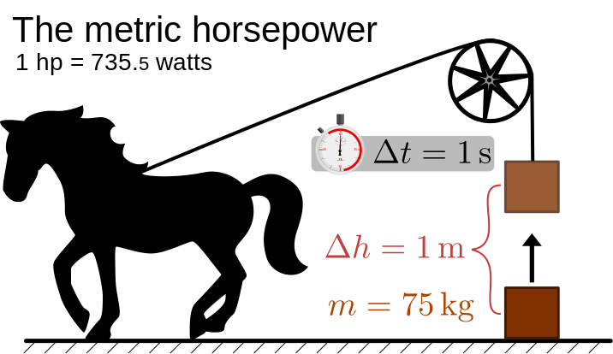

1. Show by calculation that 1.00 hp = 735 W. (2 marks)
2. If a 12.5 hp air conditioner is working for 2 minutes 15 seconds, calculate how much work has been done. (2 marks)

**Question 6 (4 marks)**

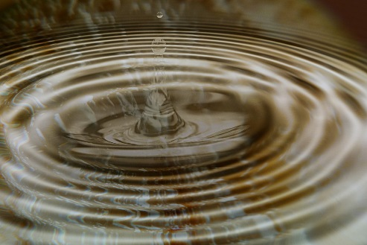 A stone is dropped into a still pool of water. It generates 20 waves that spread out a distance of 10.0 m from where it entered the water. The outer wave covers the 10.0 m in a time of 5.00 s and the average height of the waves is 10.0 mm (crest to trough).

1. Determine the wavelength and velocity of the waves. (2 marks)
2. Calculate the period of the water waves. (2 marks)

**Question 7 (5 marks)**

Sophie took 8 minutes to dry her hair with a hair dryer. During this period the hair dryer drew a current of 5.50 A from a 240 V supply.

1. Calculate much charge passed through the hair dryer in this time. (2 marks)
2. Calculate the resistance of the heating coil of the hair dryer. (1 mark)
3. Calculate the power rating of the hair dryer. (2 marks)

**Question 8 (5 marks)**

In an experiment to measure your reaction time, a partner drops a ruler through your open hand and you try to catch the ruler. The length from the start of the ruler to where you catch it can then be used to find your reaction time.

1. Assuming the ruler starts at rest, derive a formula to show how you could calculate the reaction time as a function of length. (2 marks)
2. A group of students collected the following data:

|  |  |
| --- | --- |
| **Trial** | **Distance ruler fell (mm)** |
| 1 | 41 |
| 2 | 42 |
| 3 | 38 |
| 4 | 32 |
| Average: |  |

Complete the table by calculating the average distance the ruler fell. (1 mark)

(be aware of significant figures)

1. Calculate the average reaction time as shown by the data above. (2 marks)

**Question 9 (4 marks)**

A person has decided to try Indoor skydiving. A large aeroplane engine bolted to the ground provides a very high wind, on which participants can “fly”.

1. Draw and clearly label two forces that act on a person whilst in “flight” (2 marks)

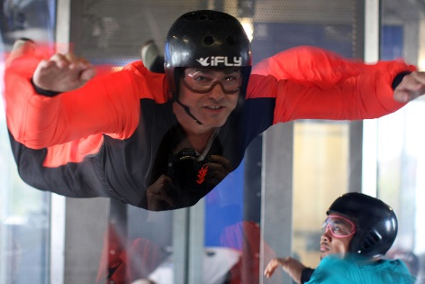

[Grab your reader’s attention with a great quote from the document or use this space to emphasize a key point. To place this text box anywhere on the page, just drag it.]

1. If a 70.0 kg person wishes to remain at a constant height, calculate the force that the wind needs to apply to them. Be sure to show your working. (2 marks)

**Question 10 (7 marks)**

On the way to school, a student decides not to use the pedestrian bridge to cross a busy road, and decides instead to run across the road. He sees a car 100 m away travelling towards him, and is conﬁdent that he can cross in time.

1. The car is travelling at 105 kmh-1 and the student can run at 10.0 kmh-1, calculate their respective speeds in ms-1. (2 marks)

Car___________________ Student ___________________

1. 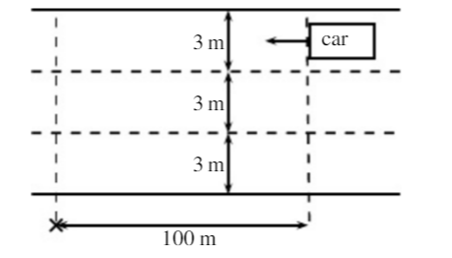If the road has 3 lanes, and each lane is 3 m wide, how long will it take for the student to cross all three lanes, from kerb to kerb? (2 marks)
2. If the car is travelling in the furthermost lane from the student, will he be able to cross all 3 lanes of the road safely? Provide a calculation as part of your reason. (3 marks)

Answer: ____________

Reason:

**Question 11 (5 marks)**

A 240 V electric kettle is used to heat 2.80 x 102 mL of water initially at 22.0 0C. The heating element draws a current of 1.80 A, and is left on for 3 minutes. Determine the final temperature of the water, assuming 85% efficiency.

**Question 12 (4 marks)**

In a game of 10-pin bowling, a person bowls a 10.5 kg bowling ball so that it hits the last remaining 1.0 kg bowling pin at 2.4 ms-1 and continues after the collision at 2.1 ms-1. The collision is head-on, so that all motion is in one dimension and we can assume no

external forces act.

1. Calculate the speed of the pin immediately after the collision. (2 mark)

1. Calculate the percentage of the initial kinetic energy lost in this collision. (2 marks)

**End of Section One**

**Section Two: Problem-solving 50% (90 Marks)**

This section has **seven (7)** questions. You must answer **all** questions. Write your answers in the

space provided. Suggested working time for this section is 90 minutes.

**Question 13 (16 marks)**

 A solar camp shower is a device to heat water for a shower when other sources of energy are unavailable. The bag is simply hung in a sunny spot for a period of time. A typical camp shower would hold 20.0 litres of water.

1. Explain why the bag is black in colour. (1 mark)

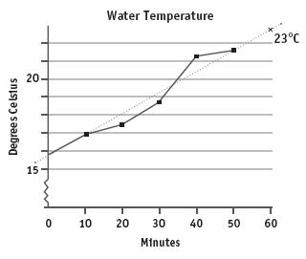

1. Examine the graph to the right, which shows how on a certain day, the temperature of water changes with time.
2. State and briefly explain one reason why the temperature of the water is not increasing at a constant rate.

(2 marks)

1. Use the graph’s line of best fit to calculate the average rate at which the water is heated. Express your answer in oC min-1.

(2 marks)

1. How long would it take to heat the water to 30.0 oC? (2 marks)
2. Calculate the amount of energy 20.0 litres of water needs to absorb to be heated from 15.8oC to 30.0oC.(1L = 1kg)

(1 mark)

1. The average amount of solar radiation received at the Earth's surface is

1.37 x 103 Wm-2. The camp shower bag has an absorbing area of 0.40 m2.

1. Calculate the rate at which solar energy falls on the bag. (2 marks)
2. If 100% of this energy was to go into heating water, how long would it take to heat 20.0 litres of water from 15.8oC to 30.0oC (3 marks)
3. Calculate the efficiency of the camp shower at converting the solar energy it receives into thermal energy in the water. (3 marks)

**Question 14 (13 marks)**

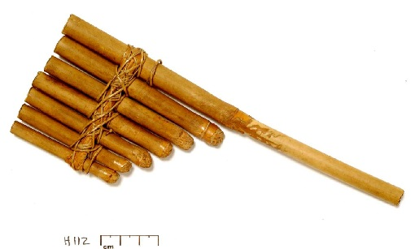 Panpipes, or pan flutes, can be traced back to Greek, Mayan, Native American, and many other ancient cultures. Although the sizes and styles differ across cultures, the basic design is a series of closed-end tubes of varying length, fixed together.

The sound is produced by blowing into the pipes and setting the column of air inside into motion. Once the wave pattern is stabilized it is known as a standing wave.

1. Will the closed end of the tube always serve as a displacement node or an antinode? Briefly explain your answer in terms of interference of waves.

(2 marks)

1. What is the relationship between the wavelength of the **fundamental** frequency and the length of the tube. (1 mark)

1. If a pipe of length 30.4 cm was made to resonate at its fundamental frequency, calculate the frequency of sound produced. (2 marks)
2. The tube is now vibrating with a standing wave pattern of three antinodes and three nodes. State which overtone this represents. Draw a **particle displacement** diagram below to aid your answer. (2 marks)

Overtone: ____________

1. A student wishes to make another pipe that produces sounds 1 octave above the 30.4cm pipe (i.e. twice its frequency). Calculate the length pipe she will have to make. Justify your answer.

(2 marks)

1. An internet guide to making your own panpipe suggests that each pipe is 9/8 the length of the previous. One of the pipes resonates at its 3rd harmonic, producing an A note of 440 Hz.

Calculate the frequency of the fundamental note produced by the pipe 3 “steps” longer than this. (4 marks)

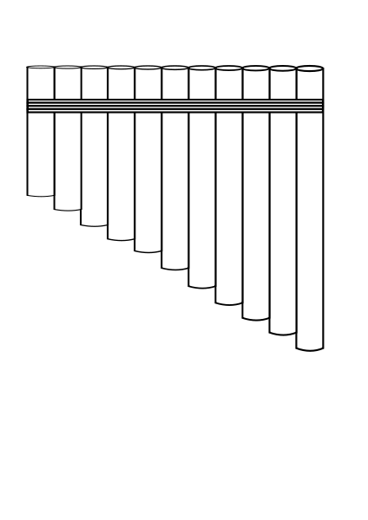

**Question 15 (14 marks)**

In an experiment, the current that passes through two separate resistors is measured as the voltage across them is changed. The results are shown in the graph below:

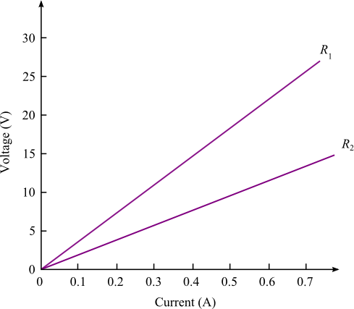

1. State whether *either, both or none* of the tested resistors are ohmic. Explain your answer. (2 marks)
2. Using the graph, determine the resistance of each, R1 and R2. Be sure to show your working.

(2 marks)

R1= ________________ R2= ________________

1. If the resistors are now joined in series, plot and clearly label their combined resistance (Rc) on the graph above. (3 marks)
2. If the current running through the series circuit is 1.80 A, determine the Potential Difference of the battery powering the circuit. (2 marks)
3. The two resistors are now placed in parallel to the same battery. An ammeter is placed in position to measure the current passing through R1 and a voltmeter is in position to measure the potential difference across R2. Draw a labelled diagram of the circuit as described.

(2 marks)

f) Determine the reading on the ammeter showing the amount of current passing through R1.

(3 marks)

**Question 16 (12 marks)**

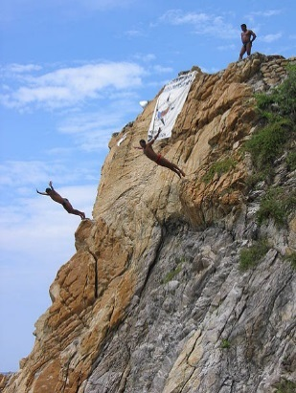 The La Quebrada Cliff Divers® are a group of professional high divers based in Acapulco, Mexico. They regularly dive head first from a height of 36.0 m into a narrow inlet of ocean water. The water depth varies from 1.80 m – 4.90 m as the ocean waves surge in and out of the inlet. The average depth is 3.60 m.

1. A diver jumped from the cliff with an initial vertical velocity of 3.5 ms-1 upwards. Calculate the kinetic energy of a 60.0 kg diver at the instant he reached the water.

(4 marks)

1. If he came to stop at a depth of 3.00 m, what average vertical force must the water exert on him? (2 marks)

1. 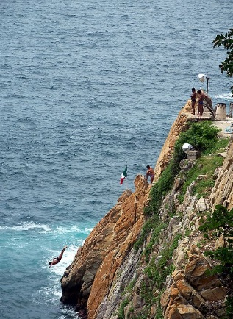The divers time their dive by observing the waves at the entrance of the inlet, to their right. The aim is to land as the wave passes under them, hence the water is at a maximum depth. Calculate how far away from the landing zone a wave peak travelling at 12 ms-1 would need to be for the diver in part a) to hit the water when at its maximum depth.

(4 marks)

1. The rocks at the base of the cliff protrude up to 4m into the water from where the divers jump. Explain, in terms of forces, why a diver would be killed if they hit these rocks.

(2 marks)

**Question 17 (11 marks)**

Nuclear Fusion is the process that powers our Sun and stars as smaller nuclei fuse together to form larger ones, and matter is converted into energy. When Hydrogen is heated to very high temperatures, its electrons are separated from the nuclei and the gas changes to a plasma. These high temperatures are also needed to overcome large repulsive forces.

1. Describe the origin of the “large repulsive forces” mentioned above. (2 marks)
2. As the temperature of the plasma rises, describe two things that happen to the particles within it. (2 marks)
3. Write a nuclear equation for the fusion of a Deuterium ( ${}_{1}^{2}H)$ nucleus and a Tritium ( ${}_{1}^{3}H)$ nucleus to form a ${}_{2}^{4}{He}$ nucleus, one other particle and energy. (2 marks)

1. Given the data below and using the formula and constants sheet, determine the amount of energy (in J) released by each such reaction. (5 marks)

m ( ${}_{1}^{2}H)$ = 2.01410178 u

m ( ${}_{1}^{3}H)=$ 3.01604927 u

m $({}_{2}^{4}{He})$ = 4.00260325 u

**Question 18 (8 marks)**

Fuses provide a way of protecting people against electrocution. They are generally a short length of wire which is designed to melt when the current in the circuit exceeds a certain amount.

1. Describe why the wire will melt when a high current passes through it. (2 marks)
2. Explain what would have to happen to the resistance of a circuit for the current to increase, and describe one situation that may cause this to happen. (2 marks)
3. In a house, a lighting circuit might use a 20.0 A fuse, whilst an oven would use 40.0 A. State which of these circuits would use a fuse with a thicker wire. (1 mark)

Answer ___________________

1. State one disadvantage of fuses, compared to a residual current device (RCD).

(1 mark)

1. List two other electrical safety devices or features commonly used in a home. (2 marks)

**Question 19 (16 marks)**

When an object such as a metal rod is heated, its length will almost always increase. A measure of the rate at which this increases is called the coefficient of linear expansion $α_{L}$. It is the fractional change in length per degree of temperature change, and can be expressed

$$\frac{∆L}{L_{o}} = α_{L}.∆T$$

Where $L_{o}$ is the initial length of the sample material, $∆L$ is the amount by which it has expanded and $∆T$ is the change in temperature.

This equation works well as long as the linear-expansion coefficient does not change much over the change in temperature and the fractional change in length $\frac{∆L}{L_{o}}$ is small

In an experiment to determine the coefficient of linear expansion of Aluminium, a sample of

known length, $L_{o}=$ 6.00 x 102 mm was placed in a sealed chamber, and heated with steam at

1.00 x 102 oC, then allowed to cool. The length of the bar was recorded each drop of 2 oC until the

temperature inside the chamber reached 50.0 oC.

1. Explain, using the Kinetic particle model of matter, why substances expand when heated.

(2 marks)

1. State what assumption must be made when collecting data for the temperature of the sample.

(1 mark)

The results for the experiment until temp = 80.0 oC are as follows:

|  |  |  |
| --- | --- | --- |
| ΔTemp (oC) | (mm) |  |
| -1 | 0.99 | 0.00165 |
| -4 | 0.97 | 0.00161 |
| -6 | 0.94 |  |
| -8 | 0.92 |  |
| -10 | 0.9 | 0.00151 |
| -12 | 0.87 | 0.00145 |
| -16 | 0.82 | 0.00136 |
| -18 | 0.79 |  |
| -20 | 0.77 |  |

1. Complete the third column, $\frac{∆L}{L_{o}}$ in the table above. Some values are already done.

(2 marks)

1. On the graph paper provided, plot a graph of $\frac{∆L}{L_{o}}$ on the y-axis and ΔT on the x-axis. You must label your axes. ( A spare grid is supplied at the end of the paper) (4 marks)

prac exam youngs mod 10 by 10

1. Draw the line of best fit for your data. (1 mark)
2. Using your line of best fit, calculate the coefficient of linear expansion for the sample used. Show all relevant calculations and working. (4 marks)
3. The theoretical value of αL for Aluminium is 23.8 x 10-6 oC-1. Calculate the percentage error in the experimental value obtained. (If you were unable to calculate a value for part f, use 23.0 x 10-6 oC-1). (2 marks)

**End of Section 2**

**Section Three: Comprehension 20% (36 Marks)**

This section contains **two (2)** questions. You must answer both questions. Write your answers in

the spaces provided. Suggested working time for this section is 40 minutes.

**Question 20 (18 marks)**

**The Great Eastern Japan Earthquake and Tsunami**

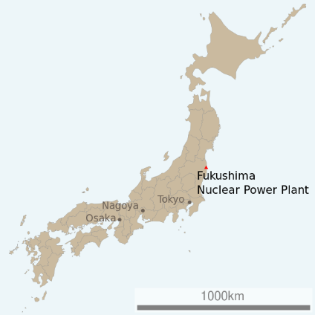

On March 11, 2011 at 2:45 pm a massive earthquake occurred off the North East Coast of Japan. The [hypocentre](https://en.wikipedia.org/wiki/Hypocenter) was at an underwater depth of approximately 29.0km.

Less than an hour after the earthquake, the first of many tsunami waves hit Japan's eastern coastline. It is estimated that the Tsunami waves were travelling at about 340 kmh-1 with wavelengths averaging 280 km when they encountered the coastline. The tsunami waves reached run-up heights (how far the wave surges above sea level as it hits the land) of up to 39 metres at Miyako city and travelled inland as far as 10 km in some places.

The tsunami waves also travelled across the Pacific, reaching Alaska, Hawaii and Chile. In Chile, some 17,000 km distant, the tsunami waves were 2 metres high when they reached the shore. The earthquake produced a low-frequency rumble called infrasound, which travelled into space and was detected by the Goce satellite.

As well as the devastation from the Tsunami, several nuclear power stations were damaged, releasing significant amounts of radioactive material into the atmosphere. Some 55,000 households were displaced and evacuation zones of up to 100km from the reactors were established.

The following table is from reports released by Japan’s Atomic Energy Commission a year after the disaster, estimating the amount of various isotopes released into the atmosphere and the ocean:

|  |  |
| --- | --- |
| **Isotope** | **Estimated amount released (TBq)** |
| iodine-131 | 511,000 |
| caesium-134 | 13,500 |
| caesium-137 | 13,600 |
| [strontium-90](https://en.wikipedia.org/wiki/Strontium-90) | 8,300 |

* Iodine-131 is easily absorbed by the thyroid, so persons exposed to releases of I-131 have a higher risk of developing thyroid disease. Children are more vulnerable to I-131 than adults. I-131 decays by beta minus and gamma emissions with a short half-life at 8.02 days.
* Caesium-137 has a long, 30-year half-life. Internal exposure to Cs-137, through ingestion or inhalation, allows the radioactive material to be distributed in the soft tissues, especially muscle and lung tissue, exposing these tissues to the beta particles and gamma radiation.
* Strontium-90 behaves like calcium (20–30% of ingested Sr-90 is absorbed and deposited in the bone and bone marrow). It undergoes β− decay into Yttrium-90, with a half-life of 28.8y.

On 22 March, World Nuclear News reported that 6 workers had received over 100mSv, and one of over 150mSv.On 24 March, three workers required hospital treatment after radioactive water seeped through their protective clothes. The injuries indicated exposure of 2000 to 6000 mSv around their ankles, with whole body doses of about 170mSv. They were not wearing protective boots, as their employing firm's safety manuals "did not assume a scenario in which its employees would carry out work standing in water at a nuclear power plant".

**Questions:**

1. As the Tsunami waves travel in deep water, they can be approximated as a sine wave. On the diagram below, clearly indicate the amplitude and wavelength of the wave. (2 marks)

displacement

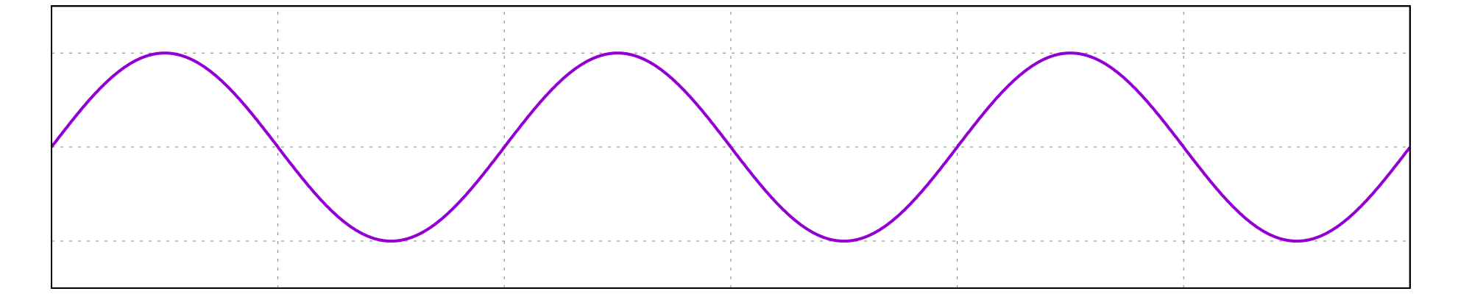

Distance from source

1. Calculate the time between two successive waves hitting Japanese the coastline. (1 mark)
2. As a result of their long wavelengths, tsunamis act as shallow-water waves. A wave becomes a shallow-water wave when the wavelength is very large compared to the water depth. Shallow-water waves move at a speed, *c*, that is dependent upon the water depth and is given by the formula:

$$c= \sqrt{gH}$$

Where ”*g”* is the acceleration due to gravity and “*H”* is the depth of water, in metres.

1. State what would happen to the speed of the tsunami wave as it approached the shore.

(1 mark)

1. Calculate how long after the earthquake the Tsunami wave would reach the shore of Chile if the average ocean depth is 3.00 km. (3 marks)
2. Explain why the wave height would only be around 2.00 m when it reached Chile.

(2 marks)

1. Complete the diagram below to show how the Tsunami waves behave around and beyond a large island.

(2 marks)

Direction of motion

1. Which of the isotopes mentioned would cause the most serious health risks in the first weeks after the incident? Explain your answer. (2 marks)
2. Calculate the percentage of the total fallout was from I-131. (1 mark)

1. Calculate the count (in TBq) of Iodine131 that remained around 32 days after the accident.

(2 marks)

1. Calculate how much energy would need to be absorbed by a 75.0 kg person for them to receive a whole body dose of 170 mSv. (2 marks)

**Question 21 (18 marks)**

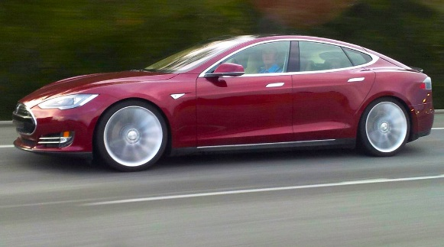 The Tesla model S, is an electric vehicle which the manufacturer claims is the third-fastest production car ever, with an acceleration of 0-100 kmh-1 in 2.7 seconds. It has a mass of 2108 kg, of which 544 kg is the battery packs.

The 2012 Model S P90D came equipped with an 85 kWh battery pack which is arranged in modules, spread under the floor of the vehicle. The 11 modules each have 9 x 3.6 V “bricks” arranged in series. This model has a stated range of 410 km on a full charge. The Environmental Protection authority measured its average energy consumption at 237.5 watt-hours per kilometre or 23.75 kWh/100 km for a combined fuel economy of 2.64 L/100 km equivalent.

The vehicle is charged by simply plugging it into a source of electricity, not unlike a mobile phone. The standard on-board charger accepts 120 or 240 Volt sources at a rate of up to 10.0 kW. An optional US$2,000 upgrade for a second 10 kW on-board charger supports a total of up to 20 kW charging from an 80 amp Tesla Wall Connector.

Questions:

1. Calculate the stated acceleration of the tesla Model S. (2 marks)
2. Calculate the average force is produced by the engine to produce this acceleration

(2 marks)

1. Calculate the total Voltage of the Model S P90D’s battery pack. (2 marks)
2. The kilowatt-hour (kWh) is a unit used to measure energy and is the amount of energy used by a 1.00 kW machine in 1 hour. Calculate the capacity of the Model S P90D’s battery pack, in Joules. (3 marks)
3. Calculate the range of the model S P90D, based upon the EPA’s testing. How does this compare to the manufacturer’s claims? (4 marks)
4. When charging from a 240V source at 10.0kW, calculate how much current is being drawn by the charger. (2 marks)
5. Calculate the minimum time it would take to re-charge a flat battery when using the

standard on-board charger. (3 marks)

**End of Questions**

**Additional working space**

**Spare grid for graph**

prac exam youngs mod 10 by 10

**End of examination**